INTERVIEW QUESTION AND ANSWER
1 What is Javascript.
Ans : JavaScript is the Programming Language for the Web.
JavaScript can update and change both HTML and CSS.
JavaScript can calculate, manipulate and validate data.

2 How Borwser Execute Javascript.
Ans : Loading: When a browser encounters a JavaScript code block or file while rendering a web page, it initiates the process of loading that code.
Compilation: the JavaScript engine compiles the code into executable code. This involves converting the human-readable JavaScript code into low-level machine code that the computer's processor can understand and execute efficiently. Modern JavaScript engines often use techniques like just-in-time (JIT) compilation to optimize code execution.
javaScript Engine : A JavaScript engine is a program or an interpreter that executes JavaScript code. It is responsible for converting the human-readable JavaScript code into a machine code that the computer can understand.
JavaScript engines are used in web browsers, servers, and other applications
that need to run JavaScript code. The most popular JavaScript engines are V8 (used in Google Chrome and Microsoft Edge), SpiderMonkey (used in Firefox), and JavaScriptCore (used in Safari).
JavaScript engines are typically developed by web browser vendors, and every major browser has one
Everything exicute in call stack : The call stack is a critical component of the the JavaScript engine's runtime environment.
Globel Exicution Context : The global execution context is the initial execution context that is created when a JavaScript program starts running. It represents the environment in which the top-level code of a script is executed. Here's an overview of the global execution context and its characteristics:
Memory Componant : the memory component refers to the memory allocation and management mechanisms used by the JavaScript engine to store and manipulate data during the execution of a program.
Code Componant : The code component in JavaScript refers to the actual JavaScript code written by developers to define the behavior, logic, and
functionality of web applications or scripts.

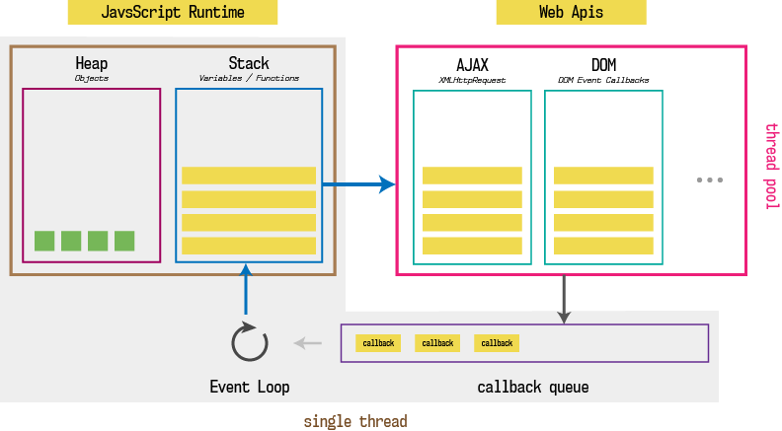

3 What are features of Javascript.
Ans :
- JavaScript was created in the first place for DOM manipulation. Earlier websites were mostly static, after JS was created dynamic Web sites were made.
- Functions in JS are objects. They may have properties and methods just like other objects. They can be passed as arguments in other functions.
- Can handle date and time.
- Performs Form Validation although the forms are created using HTML.
- No compiler is needed.
- Light Weight Scripting language :
- JavaScript is dynamically typed :
- Object-Oriented Programming support
- Functional Style
- Platform Independent
- Single threaded
- Client-side Validations

4 What is DOM ?
ANS : he Document Object Model (DOM) is a programming interface that represents the structure of HTML and XML documents as a tree-like structure. The DOM provides a way for programs and scripts to dynamically access, manipulate, and update the content, structure, and style of web pages.
Document Object Model (DOM):
- The DOM represents an HTML or XML document as a structured tree of objects.
- Each element, attribute, and piece of text in the document is represented by a node in the DOM tree.
- The DOM is hierarchical, with the document node at the top, followed by various nodes representing elements, attributes, and text nodes.
- JavaScript code can interact with the DOM to access, modify, or manipulate elements and content within a web page dynamically.
Nodes:
- Nodes are the fundamental building blocks of the DOM tree.
- There are different types of nodes, including element nodes, attribute nodes, text nodes, comment nodes, etc.
- Element nodes represent HTML elements such as <div>, <p>, <span>, etc.
- Attribute nodes represent attributes of HTML elements.
- Text nodes represent text content within HTML elements.
- JavaScript can traverse the DOM tree by navigating through nodes, accessing their properties, and manipulating their content

5 How to perform click event on Dom Using Javascript ?
ANS : Syntax. element.addEventListener(event, function); The first parameter is the type of the event (like " click " or " mousedown " or any other HTML DOM Event.) The second parameter is the function we want to call when the event occurs.

6 What is alert() and confirm() ?
Ans :
Alert Box:
- An alert box is used to inform/alert the user about an event.
- This type of popup box has only one button, named ‘OK’, and has no return value.
- Alert Box can be called using the function alert(“message”).
Confirmation Box:
- A Confirmation Box is used to provide user with a choice about an event.
- This type of popup box has two buttons, named ‘OK’ and ‘Cancel’, and return ‘true’ and ‘false’ when respective buttons are clicked.
- Confirmation Box can be called using the function confirm(“message”).

7 What is difference between undefined and null ?
ANS :
Undefined :
Undefined means a variable has been declared but has yet not been assigned a value.
It is an ECMAScript1 (ES1) feature
It does not have any syntax. But you can assign undefined to any variable but we do not do that.
It is a global property.
Null :
Null is an assignment value. It can be assigned to a variable as a representation of no value.
It is a Primitive value in Javascript
Its syntax is -: null
It is not a global property.

8. What is difference between == and === ?
Ans : The main difference between the == and === operator in javascript is that the == operator does the type conversion of the operands before comparison, whereas the === operator compares the values as well as the data types of the operands.
9. What is function . Can we overload function in javascript ?
Ans : A JavaScript function is a block of code designed to perform a particular task JavaScript function is executed when "something" invokes it (calls it)
Unlike other programming languages, JavaScript Does not support Function Overloading.
10 What is callback ? Explain with suitable example
ANS : A callback is a function that is passed as an argument to another function, and is called after the main function has finished its execution. The main function is called with a callback function as its argument, and when the main function is finished, it calls the callback function to provide a result. Callbacks allow you to handle the results of an asynchronous operation in a non-blocking manner, which means that the program can continue to run while the operation is being executed

11 What is promise? What are advantage of promise over callback.
Ans : To manage asynchronous actions in JavaScript, promises are used. It is an assurance that something will be done. The promise is used to keep track of whether the asynchronous event has been executed or not and determines what happens after the event has occurred.
Better Readability: Promises are a more structured and readable way of handling asynchronous operations. Promises allow you to chain multiple asynchronous operations together, Which makes the code more concise and clean as well as less bug-prone.

12. What is callback hell ?
Ans :

